CURRICULUM LINKS
Stan & Mags: Flight to the Past supports learning across multiple curriculum areas through a narrative-rich, inquiry-based approach that aligns with the Australian Curriculum and complements NSW teaching practice.
Rather than delivering content explicitly, the text encourages students to engage with ideas through observation, questioning, discussion, and exploration, making it well-suited to integrated and cross-curricular learning.

English (K–6)
The book strongly supports the English curriculum strands of Language, Literature, and Literacy.
Key links include:
- Reading for enjoyment and engagement
- Responding to literature through discussion and reflection
- Exploring how illustrations and text work together to convey meaning
- Making inferences and predictions based on visual and textual clues
- Building vocabulary through contextualised, meaningful language
The calm pacing and accessible yet lyrical prose make the text suitable for shared, guided, and independent reading, as well as for literature circles, particularly for students who benefit from time to observe and revisit texts.

Science & Technology (STEM)
Students are encouraged to:
- Observe and question how objects and systems work
- Explore ideas related to flight, movement, and design
- Engage in logical thinking and problem-solving
- Connect real-world artefacts to scientific and technological concepts
The story provides a springboard for computational thinking, including:
- Unplugged coding using sequencing, direction, and condition-based tasks
- Robotics activities, where students program robots to follow paths or solve challenges inspired by the story
- Visual coding (e.g. Scratch) to design simple programs, animations, or simulations based on the narrative

History & Geography

Historical Inquiry & Research Skills
Through the museum setting and artefact-based storytelling, students are encouraged to:
- Ask questions about the past and how we know about it
- Distinguish between primary and secondary sources
- Use objects, photographs, maps, and written records as evidence
- Consider whose stories are preserved and why

Local History & Place-Based Learning
The strong sense of place in the story supports:
- Investigation of local history and heritage sites
- Understanding the role of museums in preserving community stories
- Connecting learning to real places and local experiences

Geographical Inquiry Skills
The use of maps, coordinates, and spatial clues supports:
- Mapping and location skills
- Interpreting symbols and visual information
- Understanding how place influences events

Inquiry in Practice
The book provides a springboard for:
- Guided research and source comparison
- Local history investigations
- Museum or virtual museum inquiries
These experiences support an inquiry cycle of wonder → question → investigation → reflection, aligned with NSW classroom practice.

Creative Arts
The rich visual storytelling and atmospheric illustrations provide opportunities to:
- Analyse visual techniques used to convey mood and meaning
- Respond creatively through drawing, painting, or mixed media
- Create visual narratives inspired by artefacts, places, or imagined stories
Students can explore how art and illustration contribute to storytelling and communication.

General Capabilities
The text supports a number of General Capabilities, including:
- Literacy: interpreting and responding to multimodal texts
- Critical and Creative Thinking: questioning, inferring, problem-solving
- Personal and Social Capability: collaboration, discussion, curiosity
- Ethical Understanding: respect for history, heritage, and shared stories

Teacher Librarian & Inquiry Learning Use
From a NSW teacher-librarian perspective, Stan & Mags: Flight to the Past is particularly valuable for:
- Inquiry-based learning units
- Literature and STEM integration
- Museum or excursion-linked learning
- Reading for pleasure programs
- Supporting reluctant or reflective readers
The book encourages slow reading, re-reading, and discussion, making it ideal for inquiry units where depth of understanding is prioritised over speed or task completion.

BEFORE READING

Visual Literacy: Reading the Cover
Before reading the text, invite students to closely examine the cover art and title, encouraging them to interpret meaning through images.
Discussion focus:
- What information can we gain from illustrations?
- How do images help us understand a story before reading the words?

Stage-Based Prompts
Early Stage 1
- What can you see?
- Who do you think this story is about?
- How does the picture make you feel?
Stage 1
- What do you notice first on the cover?
- What might the title tell us about the story?
- Where do you think the story takes place?
Stage 2
- What clues suggest the genre of this book?
- What details might be important later?
- How do colour and mood help tell the story?
Stage 3
- How do the visual elements shape expectations?
- What themes might be suggested by the imagery?
- How does the cover position the reader?

NSW Syllabus Links
- Interpreting and responding to visual and multimodal texts
- Making predictions using textual and visual features
- Understanding how images contribute to meaning

Genre, Themes & Connections
Encourage students to predict the genre, characters, and themes, and to connect the book to others they know.

Stage-Based Prompts
Early Stage 1
- Is this a happy story or a mysterious one?
- Have you seen a book like this before?
Stage 1
- Is this a story, an information book, or both?
- What kind of adventure might this be?
Stage 2
- What themes might appear in this story?
- Can you think of similar books or stories?
Stage 3
- How does this book blend fiction and factual ideas?
- What expectations do we bring as readers?

NSW Syllabus Links
- Recognising text types and genres
- Making connections between texts
- Drawing on prior reading experiences

Anthropomorphism & Authorial Choice
Introduce anthropomorphism — animals with human qualities.
Discuss why the author may have chosen a koala and a magpie as the main characters.

Stage-Based Prompts
Early Stage 1
- Can animals talk in real life?
- How are these animals acting like people?
Stage 1
- Why do you think the author chose animals?
- How does this help us understand the story?
Stage 2
- What might these animals represent?
- How do animal characters affect how we feel?
Stage 3
- How does anthropomorphism shape meaning?
- Why might an author choose animals instead of humans?

NSW Syllabus Links
- Understanding characterisation
- Exploring authorial choices
- Discussing how texts are constructed

‘Reading’ the Illustrations
Explain that students can be co-authors as they read the illustrations and the text, building meaning together.

Stage-Based Prompts
Early Stage 1
- What is happening in the picture?
- What do you think comes next?
Stage 1
- What story do the pictures tell?
- What details stand out?
Stage 2
- What information do the illustrations give us?
- How do pictures add meaning beyond words?
Stage 3
- How do the illustrations guide interpretation?
- What is implied but not stated?

NSW Syllabus Links
- Developing visual literacy
- Making inferences
- Understanding how meaning is constructed

Symbols & the Magnifying Glass
Draw attention to the magnifying glass symbol and discuss symbolism.
Explain that it signals moments where readers are invited to look closely, investigate, and think — linking to the Missions at the back of the book.

Stage-Based Prompts
Early Stage 1
- What is a magnifying glass for?
- Why might someone use one?
Stage 1
- What could the magnifying glass mean in a story?
- What does it tell us to do?
Stage 2
- How is a magnifying glass a symbol?
- What does it suggest about the reader’s role?
Stage 3
- How does this symbol connect to inquiry?
- Why might the author repeat this visual cue?

NSW Syllabus Links
- Identifying symbols and visual cues
- Understanding purpose and audience
- Supporting inquiry-based learning

Vocabulary & Glossary Use
Introduce the glossary as a tool to support comprehension and subject-specific language. Students can create an individual or class glossary.

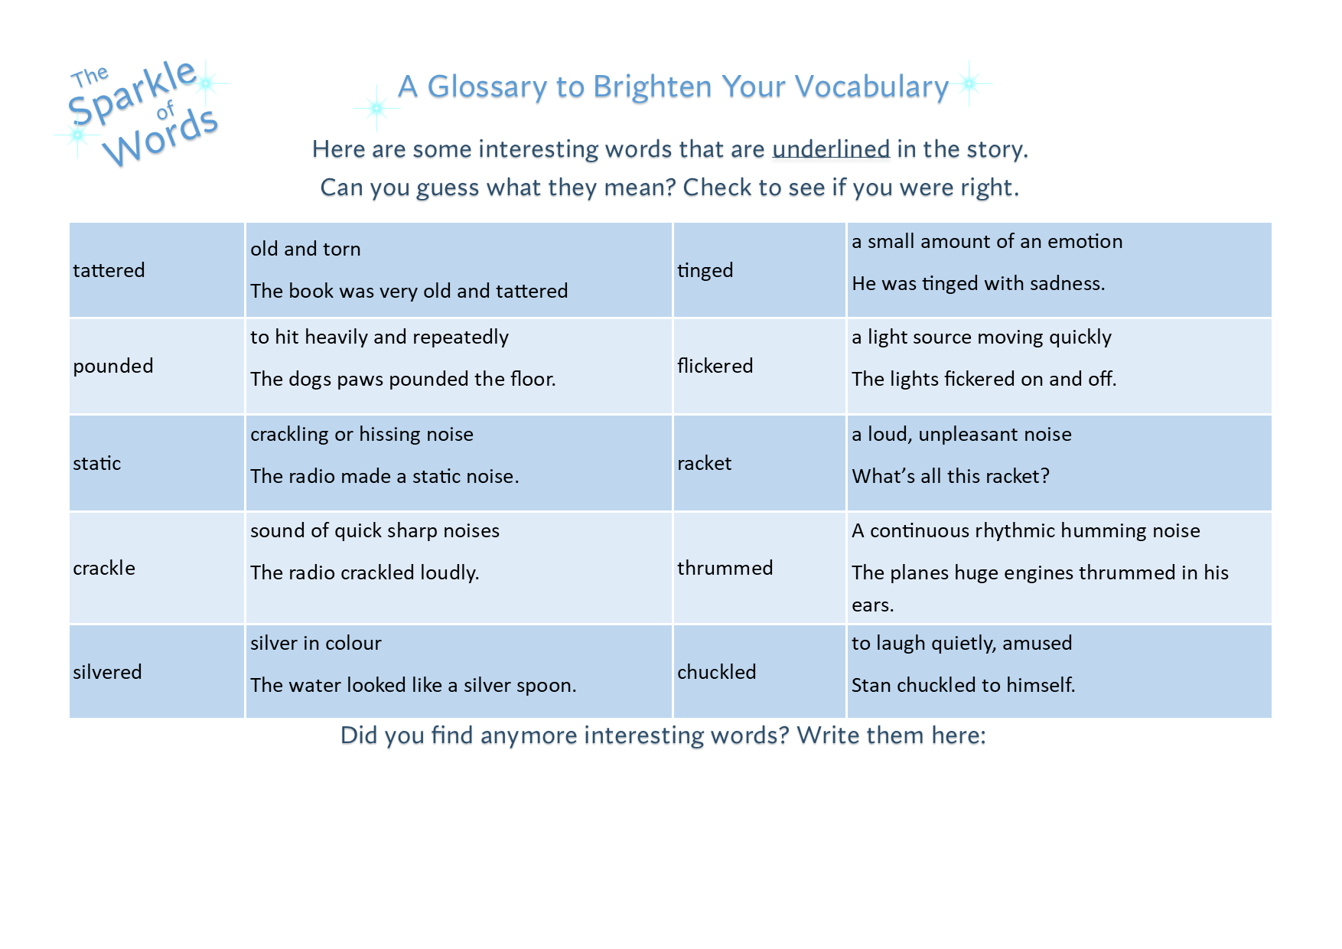

Stage-Based Prompts
Early Stage 1
- What do we do if we don’t know a word?
Stage 1
- Why might some words be new to us?
- How can a glossary help?
Stage 2
- How does learning new vocabulary help us understand the story?
Stage 3
- Why is technical vocabulary important in inquiry texts?

NSW Syllabus Links
- Developing vocabulary knowledge
- Using reference tools
- Building subject-specific language

Setting Reading Expectations
Conclude by explaining that this book encourages:
- Careful observation
- Curiosity and questioning
- Active participation
Emphasise that reading is not only about decoding words, but about thinking, noticing, and wondering — and that the story continues through inquiry and exploration beyond the final page.

DURING READING

Exploring Themes
Guide students to notice recurring ideas as the story unfolds.
Key themes include:
- Curiosity and discovery
- Friendship and belonging
- Problem-solving and perseverance
- Memory, remembrance, and helping others

Stage-Based Prompts
Early Stage 1
- How is Stan feeling?
- Who helps him?
- Are they kind to each other?
Stage 1
- How do the characters solve problems together?
- What makes a good friend in this story?
Stage 2
- How do curiosity and teamwork move the story forward?
- How do the characters change?
Stage 3
- How do themes of remembrance and helping others shape the narrative?
- Why is remembering important?

NSW Syllabus Links
- Responding to literature
- Exploring ideas and values in texts
- Understanding character development

Pause & Predict
Stop at key moments to encourage thoughtful prediction.
Prompt students to consider:
- What might happen next?
- What clues support your prediction?
- What questions do you still have?

NSW Syllabus Links
- Making inferences and predictions
- Using evidence from text and images

Language Detectives
Invite students to become language detectives, searching for expressive language. Create a word bank of literary devices and language used. Look for metaphors, similes, symbolism, alliterations, personifications, and imagery.
wings spread like silent guardians (metaphor)
planes stood like giant shadows (metaphor)
as though trying to catch a secret whisper (personification)
fur into a frenzy (personification)
eyes shining in the spotlight (simile)
their disappointment washed over them (metaphorical expression)
voice tinged with sadness (metaphor)
the glint of a rusty key (metaphor or symbol)
the engine roared to life (personification)
they soared into the night sky (personification)
an engine roared outside (personification)
scattering golden sparks that curled through the air (imagery)
- Puns and wordplay
playful or clever use of language
- Nouns and verbs describing movement
how animals move differently
- Stage-Based Prompts
Early Stage 1
- What words tell us how the animals move?
Stage 1
- Can you find a word that conjures a picture in your mind?
Stage 2
- How does the author choose words to match each animal?
Stage 3
- Why might the author choose figurative language here?
- How does word choice affect mood?

NSW Syllabus Links
- Understanding language features
- Expanding vocabulary
- Exploring figurative language

Making Connections
Encourage students to connect the text to other texts, themselves, and the world.

Text-to-Text
- Can you think of another story with animals as characters?
- Have you read a book about mystery, history, or remembering?

Text-to-Self
- Have you ever felt alone like Stan?
- Have you made a new friend?
- Have you solved a tricky problem with help?

Text-to-World
- Why do we remember people from the past?
- Why is it important that no one is forgotten?
- How can helping others make a difference?

NSW Syllabus Links
- Making personal and intertextual connections
- Reflecting on ideas and values

Writing Opportunities (During Reading)

Writing Activity Ideas
Early Stage 1
- Draw and label how an animal moves
- Write a sentence about helping a friend
Stage 1
- Write a short prediction paragraph
- Create a “movement word bank” for animals
Stage 2
- Write a diary entry from Stan or Mags’ point of view
- Describe a moment using a simile or metaphor
Stage 3
- Write an alternative scene using foreshadowing
- Create a short narrative about remembering someone

NSW Syllabus Links
- Creating imaginative texts
- Experimenting with language features
- Planning and composing texts

Teacher-Librarian Note
These during-reading strategies support:
- Deep comprehension
- Vocabulary development
- Discussion-based assessment
- Reflective and critical thinking
They encourage students to read slowly, notice deeply, and think beyond the page.

AFTER READING
After reading, students are invited to reflect on ideas, respond creatively, and extend their thinking beyond the story, reinforcing that meaning is built not only during reading but also after the last page. Explore the Sparkle of Words, Missions, and Meet the Volunteers.

Reflecting on the Story
Begin with whole-class or small-group reflection.

Discussion Prompts
Early Stage 1
- How did the story make you feel?
- Who was kind or helpful?
Stage 1
- What was the problem in the story?
- How was it solved?
Stage 2
- What message or lesson do you think the story shares?
- What was the most important moment?
Stage 3
- What ideas stayed with you after finishing the book?
- Why do you think the author chose an open ending?

NSW Syllabus Links
- Responding to literature
- Identifying ideas and messages
- Reflective thinking

Revisiting Themes & Big Ideas
Return to key themes and consider how they developed.
Focus themes:
- Curiosity and inquiry
- Friendship and belonging
- Problem-solving and perseverance
- Remembrance and helping others

Prompts by Stage
Early Stage 1
- How did the characters help each other?
Stage 1
- How did being curious help solve the problem?
Stage 2
- How did the characters change during the story?
Stage 3
- How do the themes connect to real life?

NSW Syllabus Links
- Exploring themes and values
- Character development
- Making meaning from texts

Creative & Analytical Response Activities

Writing & Response Options
Early Stage 1
- Draw a favourite moment and explain it
- Draw something you would keep in a museum
Stage 1
- Write a sentence about helping a friend
- Draw and label an object from the story
Stage 2
- Write a diary entry from Stan or Mags’ perspective
- Create a short reflection on a theme
Stage 3
- Write an alternative ending or epilogue
- Write a reflective paragraph about remembering someone or something important

NSW Syllabus Links
- Creating imaginative texts
- Expressing personal responses
- Planning and composing texts

Making Deeper Connections
Encourage students to extend their thinking through connections.

Text-to-Self
- Have you ever felt unsure or alone?
- When have you helped someone else?

Text-to-World
- Why is it important to remember people from the past?
- How do museums help us remember?

Text-to-Text
- Can you think of another story about discovery or remembrance?
- How is this story similar or different?

NSW Syllabus Links
- Making connections
- Reflecting on values and experiences

Extending the Inquiry (The Story Continues)
Introduce the idea that the story does not end with the book.
Extension options:
- Complete the Missions at the back of the book
- Explore Morse code, mapping, or biomimicry
- Research a local museum or historical figure
- Create a class “mini museum”

NSW Syllabus Links
- Inquiry-based learning
- Research and investigation
- Cross-curricular learning

Metacognition: Thinking About Thinking
Encourage students to reflect on their learning.
Stage 2–3 prompts:
- What did you learn from this story?
- What questions do you still have?
- How did your thinking change?

NSW Syllabus Links
- Reflective learning
- Critical and creative thinking

Teacher-Librarian Note
This after-reading sequence supports:
- Deep comprehension
- Reflective discussion
- Creative response
- Inquiry beyond the text
It reinforces the idea that reading is not finished when the book is closed, but continues through thinking, questioning, and exploration.

ABOUT THE AUTHOR

Susan J. Wright is a former primary school teacher and teacher librarian with over 23 years of experience in education across the UK, Kuwait, and Australia. Throughout her career, she has been deeply inspired by the magic of belief, dreaming, and imagination — and by the power of stories to light up children’s faces when a book truly connects.
As a teacher librarian, Susan developed a unique insight into how children learn to read and what draws them into stories. Her work is informed by a strong understanding of phonics, emergent readers, and reading for pleasure, as well as an intuitive sense of what children respond to emotionally and creatively. She is a qualified Reading Recovery teacher and holds certification in teaching English as a Second Language to adults.
Susan holds a Bachelor of Education and a Master’s degree in Teacher Librarianship, and is currently completing a Master’s in Creative Writing. She is a passionate advocate for preserving history through storytelling and for raising the profile of reading as something joyful, imaginative, and deeply human — not just a skill to be mastered.
Her writing blends factual content with narrative, creating creative nonfiction hybrid stories that invite readers to dip in, explore, and wonder. Susan’s work encourages curiosity, connection to community, and a sense of adventure — even for grown-ups who still believe in magic.
Stan & Mags: Flight to the Past, inspired by Fighterworld Museum at Williamtown, is her debut children’s picture book. She hopes it becomes someone’s future favourite.
Susan lives near Newcastle, NSW, with her husband, daughter, and three German Shepherds.

